SHAHEFENDI SHARI
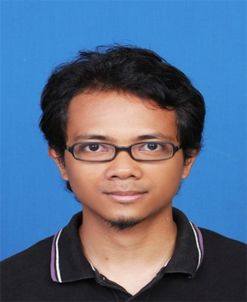
No. 27, Jalan 4/2B,
Bandar Nusaputra, Presint 2,
47130 Puchong,
Selangor Darul Ehsan

To secure a position in the organization that offers challenge and opportunity for my career development and at the same time serve the organization to the best of my capabilities. I would like to gain new skills while utilizing my current area of expertise.

PERSONAL INFORMATION

Born: July 9th, 1985
Citizenship: Malaysian
Marital status: Single
Mobile No. : +60123179364
Email: shahefendi.shari@gmail.com

WORK HISTORY

01.2014 - present astro
Network Scheduler (Media Planning)
- To apply knowledge of channels' content and channel promotion campaigns when planning promo scheduling strategy.
- Able to meet and fulfill regional client's request concerning scheduling matters.
- To regularly update following schedule changes i.e. programs change, promo urgent loading, promo urgent kill etc.
- Persistent and active communication with channels and operation teams.
- Meeting daily operation requirements and datelines associated with the scheduling of promotions for regional channels.

01. 2013 – 12. 2013 ibm malaysia
IT Support Helpdesk
- To provide 1st level support via e-mail or telephone
- To process end users' IT requests and coordinate 2nd level support between users and the relevant team leads
- Troubleshoot regarding Lotus Notes
- Perform hands-on installation and troubleshooting of IT hardware & software in a large and fast paced user environment

07.2012 – 12.2012 media monitors sdn bhd
Media Research Specialist
- Monitor advertisement on media in the US, primarily radio advertisement. Discover title and verify commercials that are broadcasted for the first times to be then processed for online reporting.

01.2012 – 04.2012 two tones sdn bhd
Multimedia Editor (Intership)
- Compositing digital and live action elements to create industry-quality visual effects shots.
- Prepare design presentation and compiling material
- Provide graphic design services for posters, banners, streamers, online branding and photo manipulation
- Visual Editing using Photoshop
- Post Production work using Adobe Premier, Adobe After Effects.

01.2008 – 07.2008 Telekom malaysia
Technician
- Installation of TM Telephone line & Streamyx at customer premises & Testing Network Connection.
- Setup & Configure ADSL Modem and Wireless for internet connection.
- Joint a cable from pole, underground, and Main Distribution Frame to customer premises.
- Did some renovation (drilling) to adjust with customer needs.

EDUCATION

2008 – 2012 multimedia university
Bachelor of Management Majoring in Media Innovation & Management
- CGPA – 2.91

2003 – 2007 multimedia university
Diploma in Telecommunications Engineering
- CGPA – 2.70

PROFESSIONAL CERTIFICATES

- Safety and Health Officer Course (Attending Course Certificate) from Consist College
- First Aid Training under Astro

references

- Syazwan Abdullah - +6017 224 8601 (Astro)

